CITY OF CORAL GABLES
--MEMORANDUM--
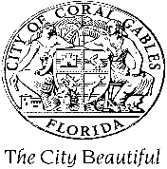
TO: Members of the City Commission
City Manager, Peter Iglesias
Chief of Police, Edward Hudak
FROM: Mayor Vince Lago

DATE: August 26, 2022

SUBJECT: Electronic Vehicles for our Police Fleet

Please let this memo serve as a formal request for staff to consider assessing the usage of electronic vehicles by our Coral Gables Police Department. Currently, the city has the largest municipal government electric vehicle fleet in the state of Florida. As noted in our Strategic Plan, sustainability and resiliency is a top priority in our city. As such, we must consider integrating sustainable practices in our planning, policies, and services.
Please see link attached for information on electronic vehicles for your consideration:
Meet the 2024 Chevy Blazer PPV EV (electrek.co)

